Dymo printing instructions for RX labels

1. Make sure you’re using the following printer and label size (be sure you don’t use the starter labels that come with printer).  
   1. Rx bottle label printer – <http://www.amazon.com/DYMO-Writer-printer-Labels-1752266/dp/B0027J9KH6/ref=sr_1_2?ie=UTF8&qid=1379888841&sr=8-2&keywords=dymo+turbo+450>
   2. Rx bottle labels, 4x2 – <http://www.amazon.com/gp/product/B001AVMFR4/ref=oh_details_o02_s00_i00?ie=UTF8&psc=1>
2. It’s best to always print the RX label directly from the Adobe PDF reader which you can install here: <https://get.adobe.com/reader/>
3. After you add the prescription in Atlas and click the “Dispense and Print” button it will generate a PDF label that looks like this:

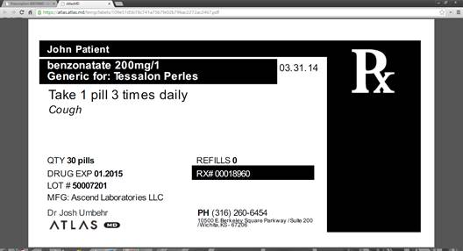

1. When it starts to download, you’ll see it in the bottom left hand corner of the chrome window.  The arrow next to the downloading file will give you the option to automatically open these types of files which mean it will always open in Adobe and save you an extra step.  See picture on next page.

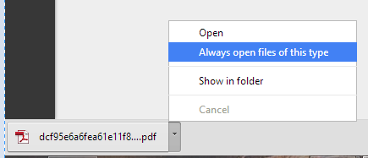

1. Once in Adobe, click the print button and you’ll see options like the picture below. Be sure you match your print to all the highlighted sections.   
   